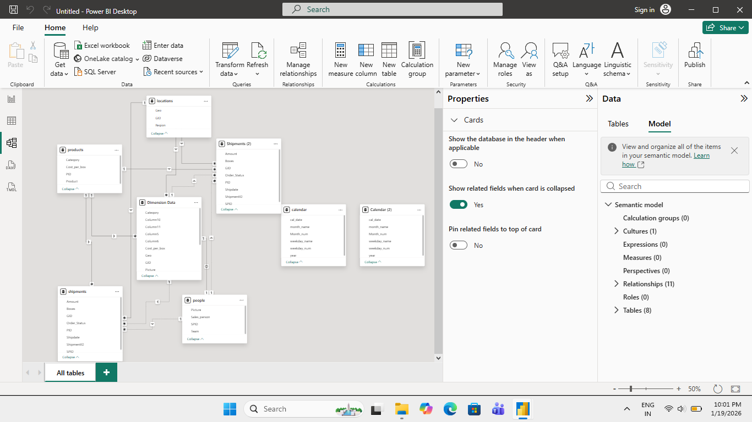
1.1Model view Before 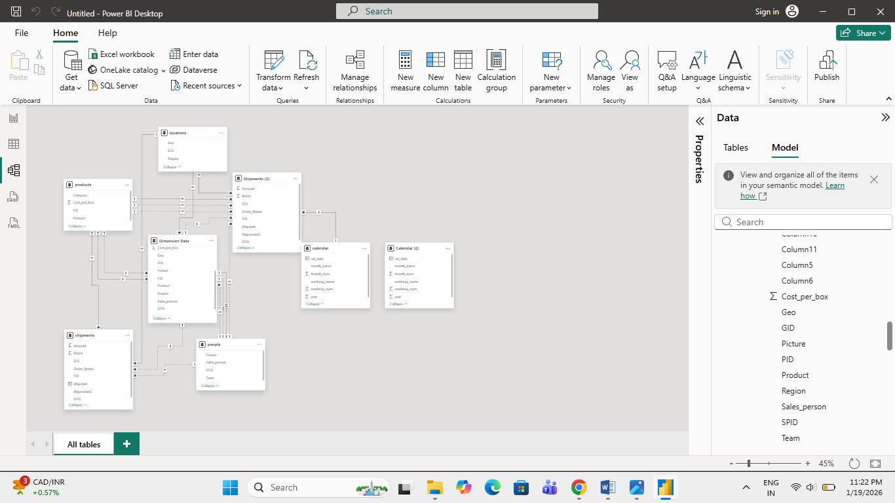
1.2Model View After
I crea New relationship between (People ↔ Calendar)
A salesperson (People) can make many shipments
Those shipments happen on different dates (Calendar)
One person → many dates
One date → many people
Also I make a relationship between products (shipments) having order status (calendar) cal_date.

